APPENDIX B: DIRECT VOTER CONTACT

Below are the direct postcards mailed to voters for the March 5, 2024, Presidential Primary Election.

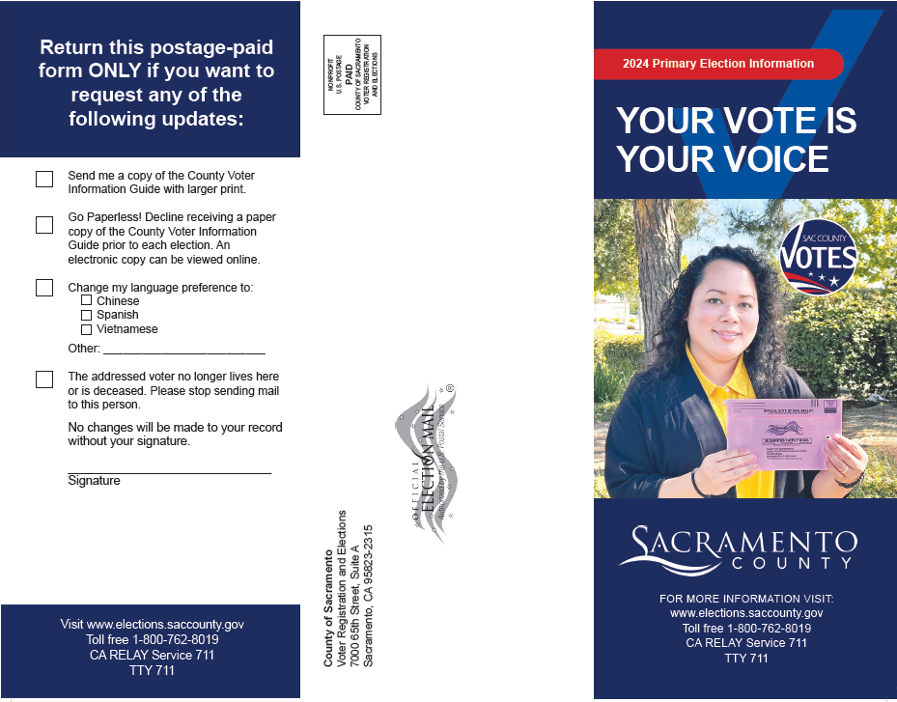
Direct Voter Contact Postcard 1 – March 5, 2024 Presidential Primary Election

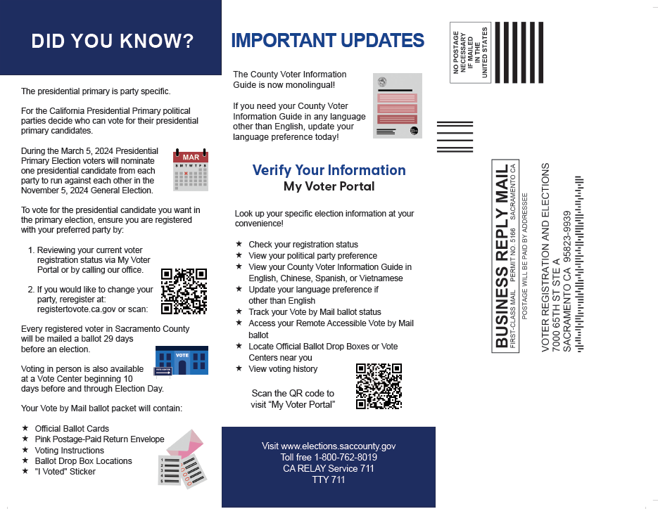

Direct Voter Contact Postcard 1 – March 5, 2024 Presidential Primary Election Continued
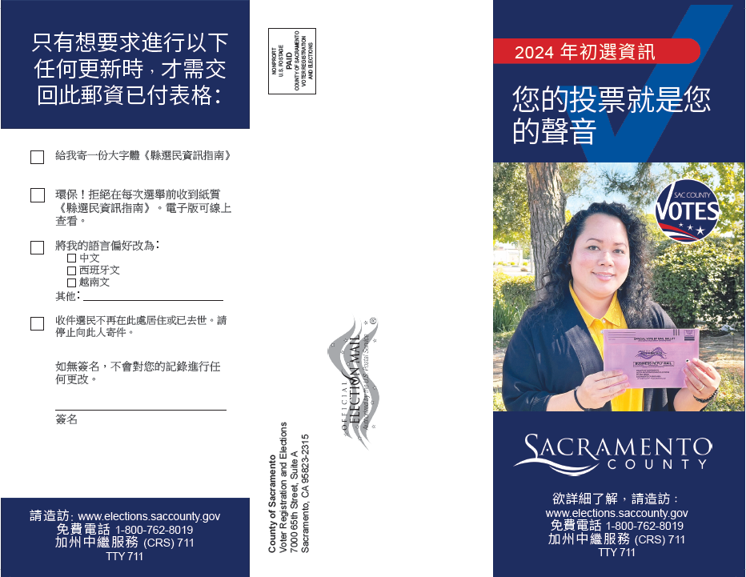

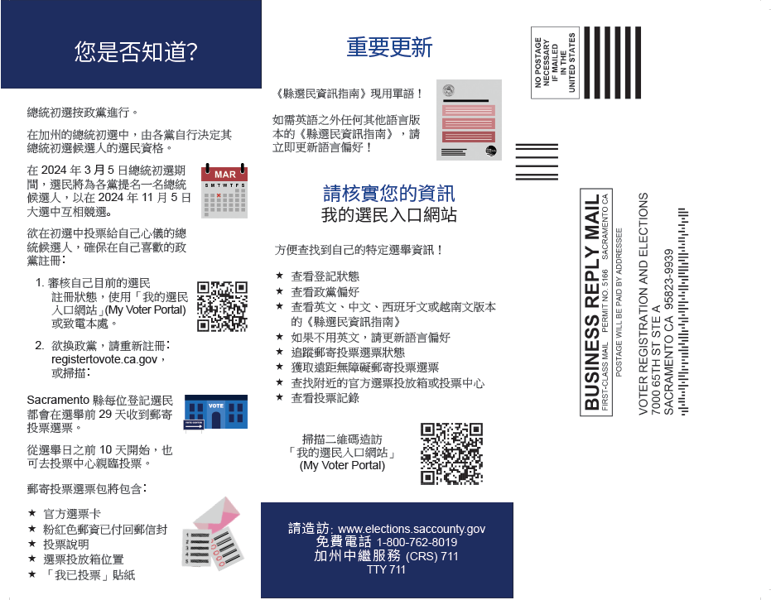

Direct Voter Contact Postcard 1 – March 5, 2024 Presidential Primary Election Continued
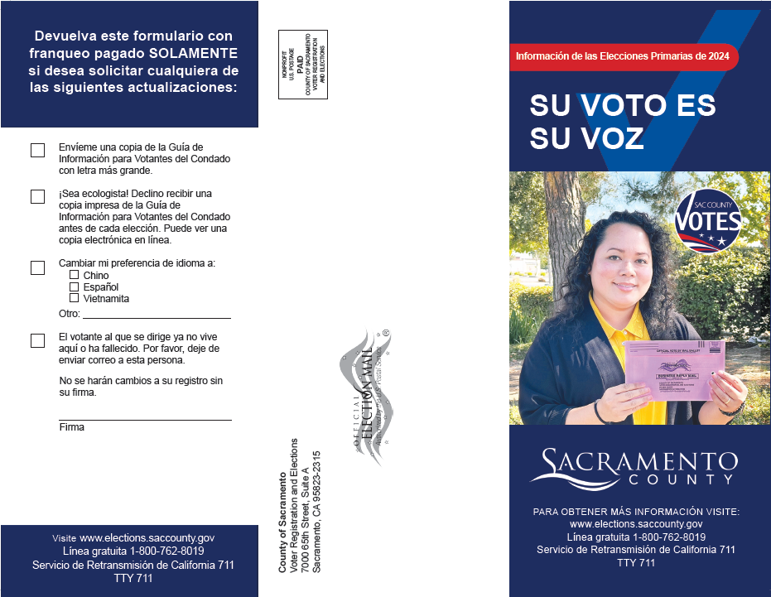

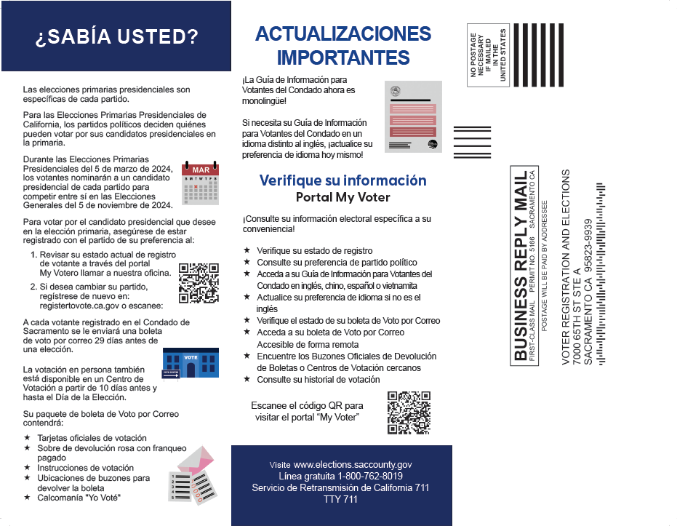

Direct Voter Contact Postcard 1 – March 5, 2024 Presidential Primary Election Continued
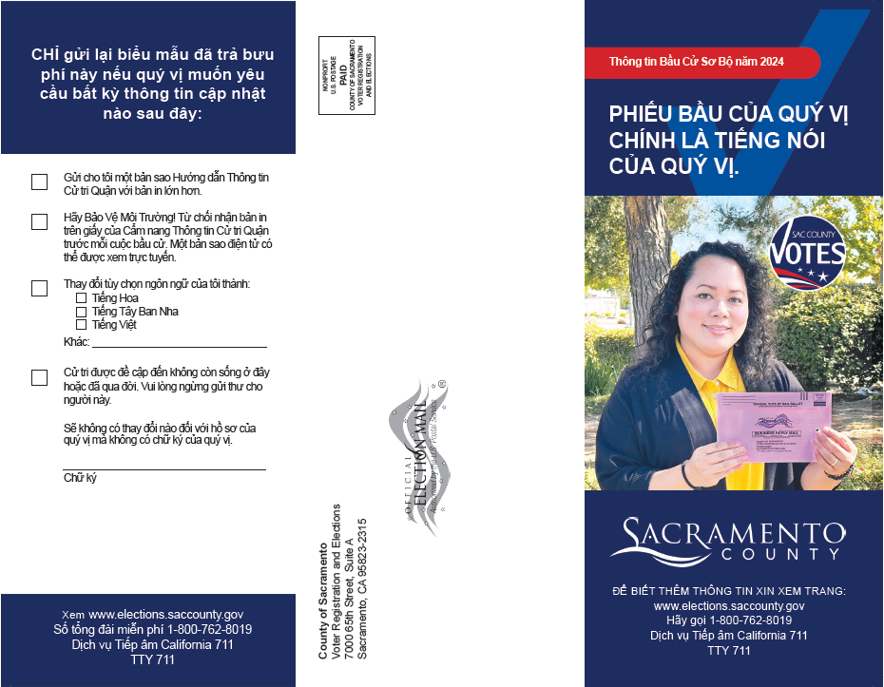
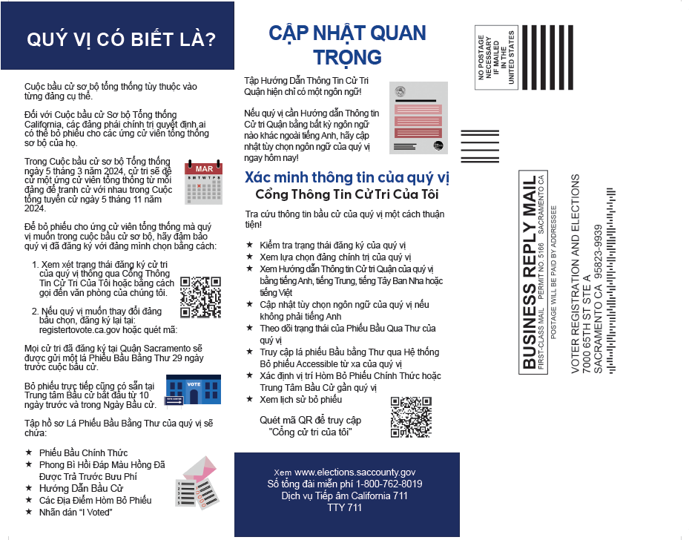
Direct Voter Contact Postcard 2 – March 5, 2024 Presidential Primary Election
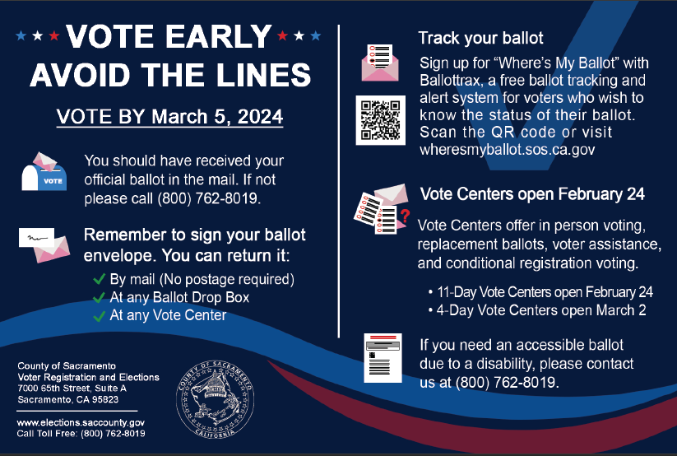

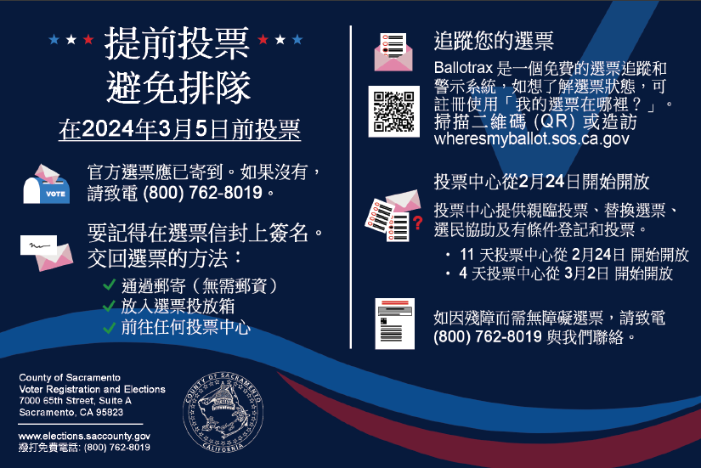

Direct Voter Contact Postcard 2 – March 5, 2024 Presidential Primary Election Continued
